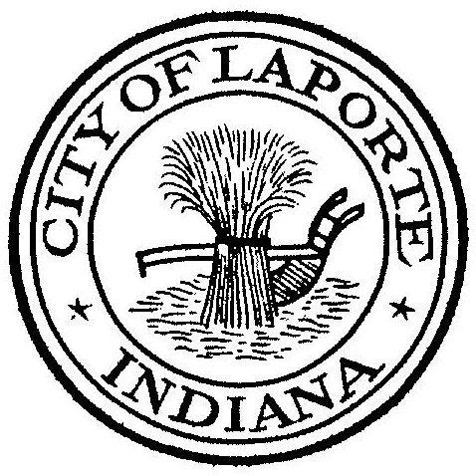
Board of Public Works and Safety
Jessica Romine, Member Tom Dermody, Mayor Mark Kosior, Member
City Hall 801 Michigan Ave., La Porte, IN 46350
Tuesday, July 18, 2023
9:00 AM
AGENDA
- Call To Order
- Pledge Of Allegiance
- Approval Of Minutes
- Public Comment: In Person and via Facebook Live
- Clerk-Treasurer: Claims Approval
David Albin Water Bill Appeal
- Department Head Reports
- New Business:
-Nick Otis: Settlement Agreement
Engagement Letter
-Jerry Jackson: Basement Backup Grant: 807 Adams St.
Letters/Numbers Pay Request #3 Contracts 2B/2A
Vactor Bids
-Nick Minich: Contract Amendment-United Consulting Emergency Vehicle Preemption
(Construction Inspection)
-Paul Brettin: LP Social Worker MOU 2024
LP MOU Mental Health Professional
8) Unfinished Business:
9) Other Business: Next regularly scheduled meeting: Tuesday, August 8, 2023 at 9a
10) Adjourn

